ASSESSMENT 1
Dataset:
https://github.com/TopsCode/Data_Analysis_2024/blob/main/ALL_CSV/banklist. csv

- Import pandas and read in the banklist.csv file into a dataframe called banks.
- Show the head of the dataframe

Ans:
import pandas as pd
import numpy as np

banks = pd.read_csv("C:/Users/sonyd/Downloads/banklist (3).csv")
banks.head()

output:
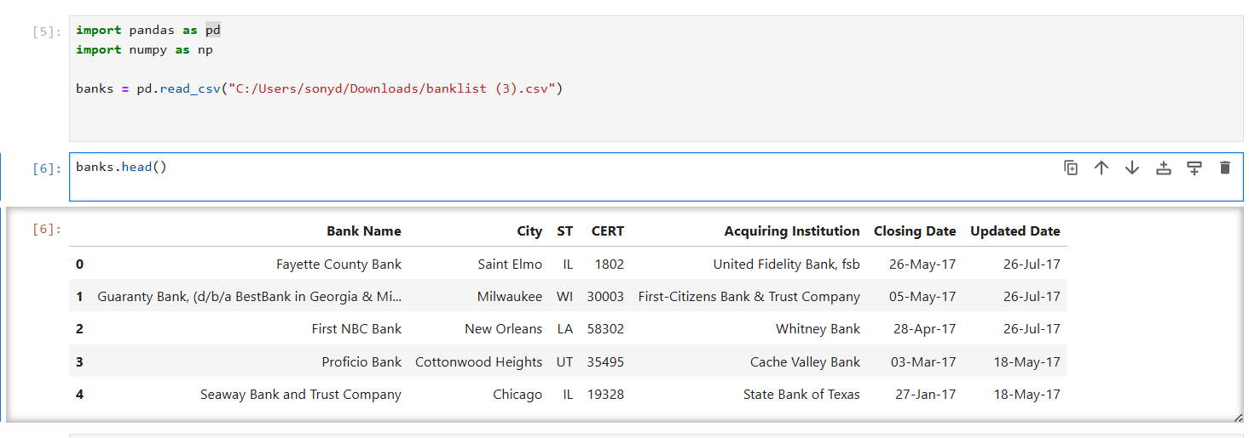
3) What are the column names?
Ans:
banks.columns
output:
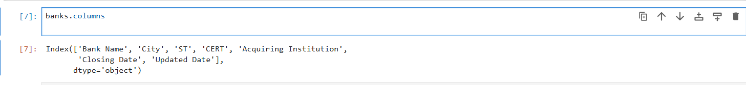
- How many States (ST) are represented in this data set?
Ans:
banks['ST'].value_counts().shape[0]

output:

- Get a list or array of all the states in the data set.
Ans :
states = banks['ST'].value_counts().index
states

output:

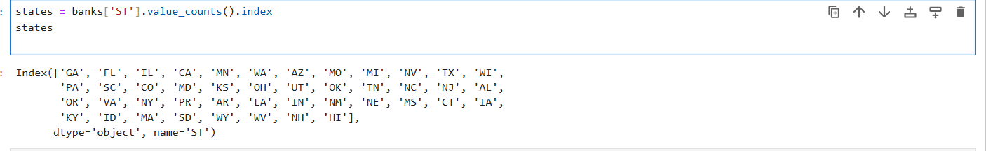

- What are the top 5 states with the most failed banks?
Ans:
banks['ST'].value_counts().head(5)

output:
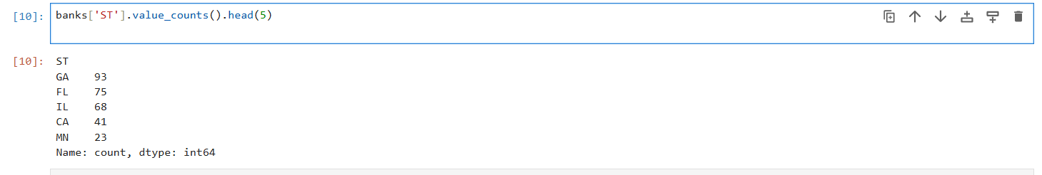

- What are the top 5 acquiring institutions?

Ans:
banks['Acquiring Institution'].value_counts().head(5)

output:
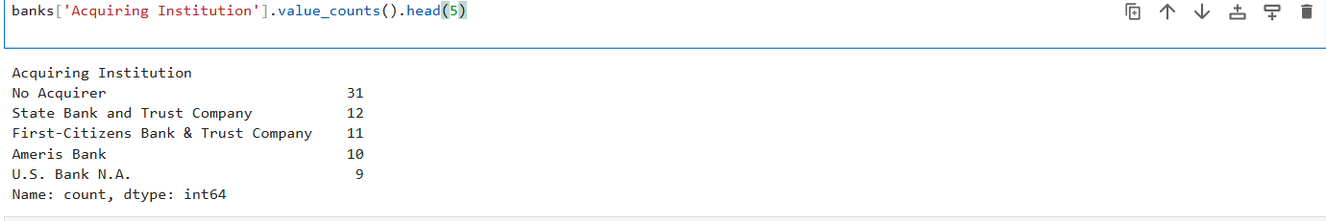

- How many banks has the State Bank of Texas acquired? How many of them were actually in Texas?

Ans:
import numpy as np

acq = banks['Acquiring Institution'].values
st = banks['ST'].values

total_sbt = np.sum(acq == 'State Bank of Texas')
tx_sbt = np.sum((acq == 'State Bank of Texas') & (st == 'TX'))

total_sbt, tx_sbt

output:
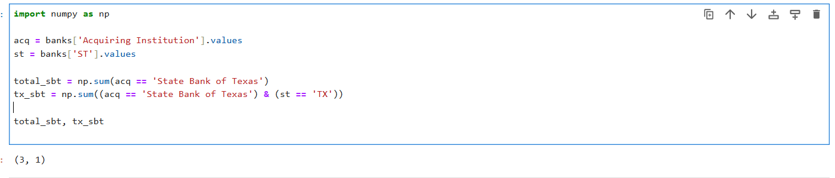

- What is the most common city in California for a bank to fail in?
Ans:
banks[banks['ST'] == 'CA']['City'].value_counts().index[0]

output:

Module 8: NumPy, Pandas, Matplotlib Libraries
Assessment 2:
Dataset: https://github.com/TopsCode/Data_Analysis_2024/blob/main/ALL_CSV/historical_autom obile_sales.csv

Q 1: Develop a Line chart using the functionality of pandas to show how automobile sales fluctuate from year to year.

Ans:
import pandas as pd
import matplotlib.pyplot as plt
import seaborn as sns

df = pd.read_csv("C:/Users/sonyd/Downloads/historical_automobile_sales (1).csv")
df.head()

yearly_sales = df.groupby("Year")["Automobile_Sales"].sum()

yearly_sales.plot(kind="line", figsize=(10,5), marker='o')
plt.title("Yearly Automobile Sales Trend")
plt.xlabel("Year")
plt.ylabel("Total Automobile Sales")
plt.grid(True)
plt.show()

output:
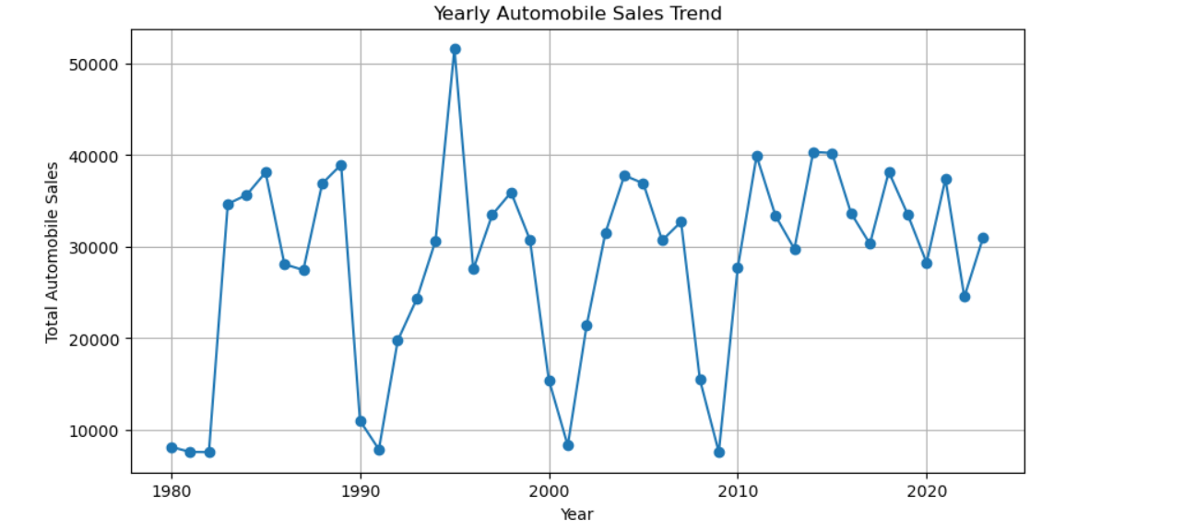

Q 2: Plot different lines for categories of vehicle type and analyze the trend to answer the question Is there a noticeable difference in sales trends between different vehicle types during recession periods?

Ans:
recession_df = df[df["Recession"] == 1]

plt.figure(figsize=(10,6))
sns.lineplot(
data=recession_df,
x="Year",
y="Automobile_Sales",
hue="Vehicle_Type",
marker="o"
)

plt.title("Sales Trend by Vehicle Type During Recession")
plt.xlabel("Year")
plt.ylabel("Automobile Sales")
plt.show()

output:
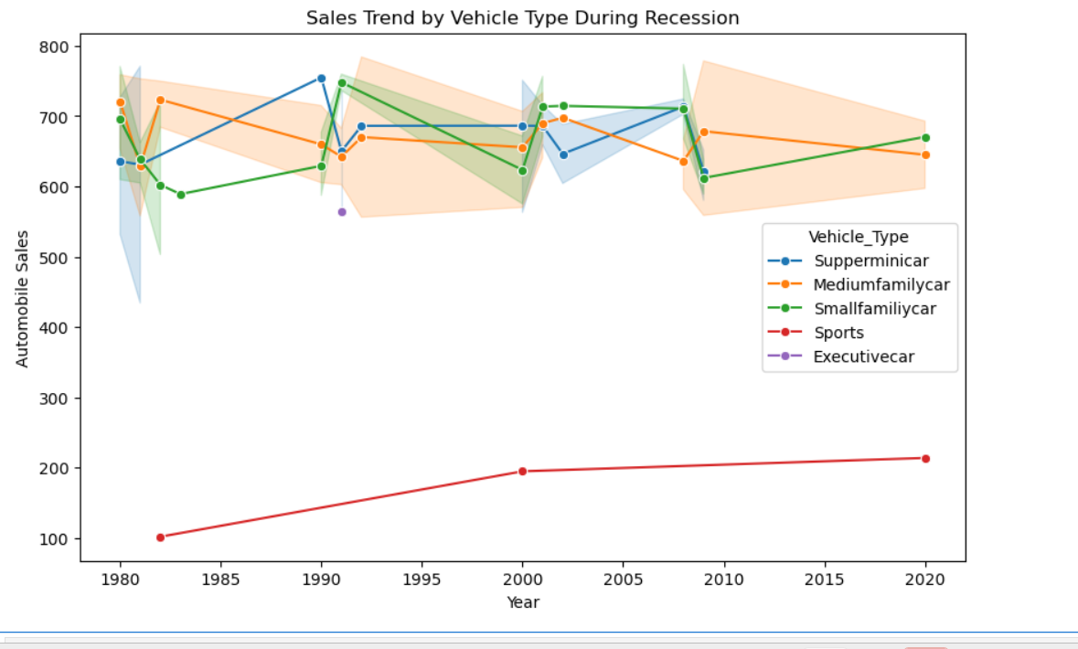

Q 3: Use the functionality of Seaborn Library to create a visualization to compare the sales trend per vehicle type for a recession period with a non- recession period.

Ans:
plt.figure(figsize=(10,6))

sns.barplot(
data=df,
x="Vehicle_Type",
y="Automobile_Sales",
hue="Recession"
)

plt.title("Automobile Sales: Recession vs Non-Recession")
plt.xlabel("Vehicle Type")
plt.ylabel("Average Automobile Sales")
plt.xticks(rotation=30)
plt.show()

output:
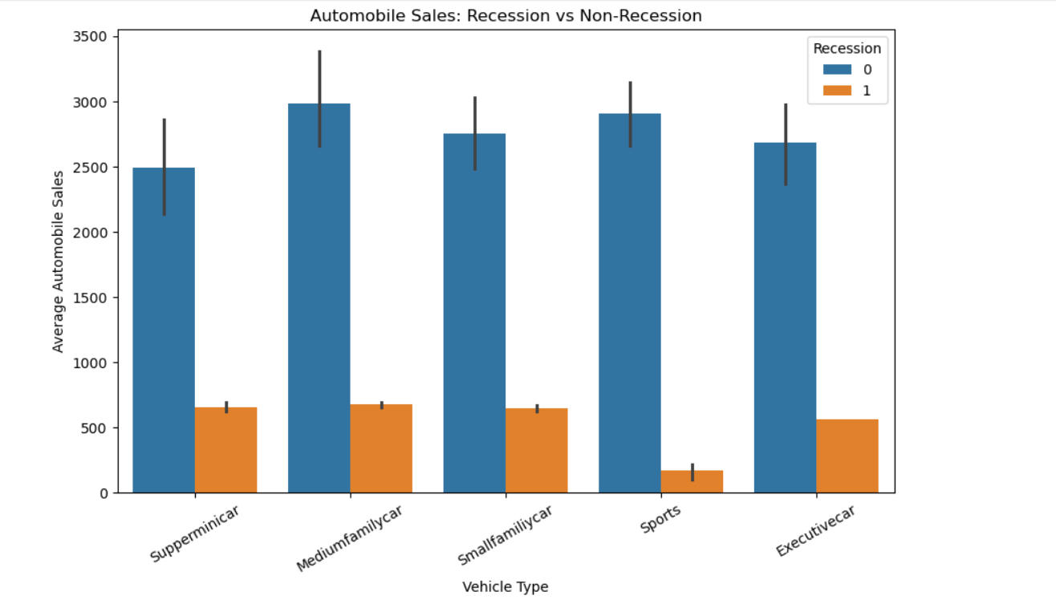

Q 4: Now you want to compare the sales of different vehicle types during a recession and a non-recession period

Ans:
avg_sales = df.groupby(
["Vehicle_Type", "Recession"]
)["Automobile_Sales"].mean().unstack()

avg_sales.plot(
kind="bar",
figsize=(10,6)
)

plt.title("Average Automobile Sales by Vehicle Type")
plt.xlabel("Vehicle Type")
plt.ylabel("Average Automobile Sales")
plt.xticks(rotation=30)
plt.show()

output:
